Chapter 17, Problem 69.

Use PSpice to obtain the Fourier coefficients of the waveform in Fig. 17.55(a).

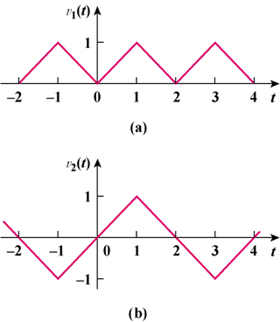

Figure 17.55
For Prob. 17.69.

